Shepherd’s Bethel Chronicle
September 2019
“As the mountains are round about Jerusalem, so the Lord is round about his people from henceforth even forever.” Ps 125:2
Phone: 812-9369648, e-mail: shepbeth@shepherdsbethel.org, web page: shepherdsbethel.org
Hughes Paving lays down the blacktop!
Pictured below is the preparation of the gravel base and final coat of 3” blacktop completed for Enoch’s Abode driveway. Thank you again for all who gave to make this prayer request a reality.
I hauled in about 12 truckloads of gravel and leveled and compacted the driveway. Steve formed and prepped the sidewalks; and with some missionary help, we poured the concrete.
Wayne Hughes who owns the paving company, is pictured running the hand compactor. He and his men did a marvelous job laying, leveling, and finishing the drive and parking area.
Not only was his bid a couple thousand below the nearest competitor, but his final bill to the mission was a couple thousand below what he bid.
He graciously poured more area, thicker blacktop, and 10 additional radius driveway pours at no additional cost.
As you can tell by the pics, they worked through rain and everything to accomplish this wonderful addition to Enoch’s home.

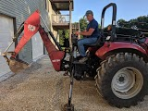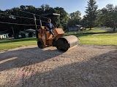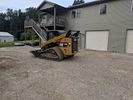
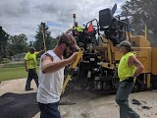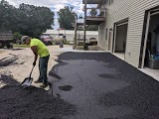
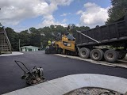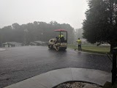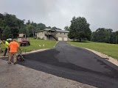

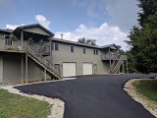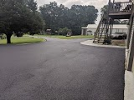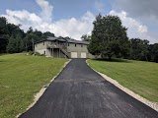
Please pray with us for some fall help fixing the two staircases, laying the brick underneath the landing area, and covering the cinder block with decorative facial stone. Thank you all again for praying and supplying for missionary housing. Together we have served well over 1,000 families with rent free homes.
We also found the time to plan and prepare a 50th anniversary reception for a sweet couple from here. Denzil & Rita Brown are pictured below with some of the family during the afternoon celebration. They have been long time friends of the mission. Rita knew my mother when she was here, and was working on site with mom when my wife Susan called letting mom know she had accepted Christ as her Savior! (Small world)
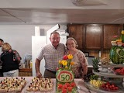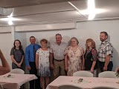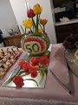
Speaking of fiftieth anniversaries, 2020 will mark 50 years since Mom & Dad left Chicago to build SBBM. We officially began serving guests in 1971. May God be glorified!

